Regional Ambassadors
Regions
LAPA is sub-divided into 9 regions. The purpose of the regional groups is to facilitate communication and networking amongst PAs who live and work in the same geographical region. Additionally, each region roughly corresponds with legislative districts.
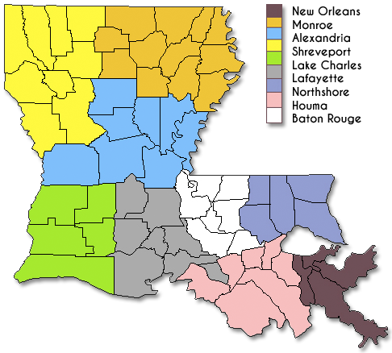
Regional Ambassadors
The role of the Regional Ambassadors is to coordinate communication and events within their respective regions, and to serve as a liaison between the LAPA board of directors and LAPA members. These are voluntary positions and not members of the board of directors. Ideally one would serve as a Regional Ambassador for a period of one year (July-June, coinciding with BOD terms).
Responsibilities include:
- Coordinate drug-rep sponsored dinners within the region
  - Coordinate invitation/agenda
  - Assist organization managers with posting/sharing to social media- cc the LAPA VP along with the Management company- currently Plan It Satisfaction- Monique Ochoa monique@ourlapa.org
  - Assist with collecting RSVPs for vendor
  - Attend dinner if possible. If you can’t, assign an attendee to facilitate
  - Create a short agenda and update membership. Bring any concerns back to the LAPA BOD
- Serve as a board liaison/point of contact for local practice and/or legislative issues within the region
- Assist with legislative outreach/grass roots advocacy within the region
- Assist organization managers with recruitment and retention of LAPA members (Stephen Quick stephen@ourlapa.org )

